URL: <http://www.kono-dental.com/english/>

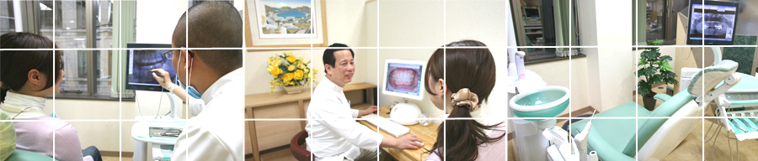

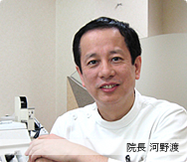 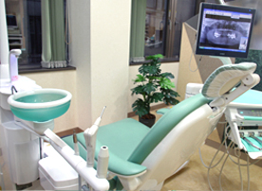 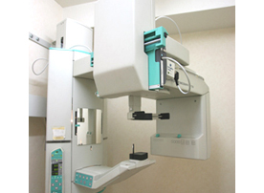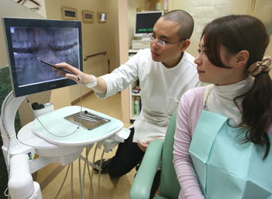

All dental work undertaken: from check-ups, cleaning to “state of the art” computer-aided design porcelain fillings and crowns.

Sensitive and nervous patients are particularly welcome.

**Testimonials**

From Jeremy K. Wood, from Indiana, U.S.A. 　I have visited several clinics in Osaka trying to find good doctors who can speak English well. And today I found a great Dental Clinic. I have decided to write this testimonial, without being asked, to let other foreigners known that Kono Dental Clinic is the first and last Dentist they should visit while in Osaka. Not only can the Dentist speak great English, but some of the other staff can as well. Also, the equipment is topnotch--better than my Dentist in America. I can highly recommend going to this clinic.

Jeremy K. Wood 2009/10/9

**Specialties**

1. General Dentistry
2. Orthodontics
3. Periodontal Treatment
4. Whitening
5. Cosmetic Dentistry
6. Implant Occlusal Treatment
7. Preventive Dentistry
8. Laser Treatment
9. Oral Surgery
10. Acupuncture
11. DNA Banking etc

**Doctor’s credentials**



**Director: Dr.Wataru Kono**

Wataru Kono.DDS. Phd. Acupuncturist

Birthday: May 10th 1952

* 【Educational History】
* Graduated from Osaka Kyoiku Univ.attached Tennoji High School
* Graduated from Nihon University School of Dentistry
* Graduated from Osaka Acupuncture-and-Moxibustion
* Vocational School(Present: Morinomiya Medical Vocational School）
* 1991:Doctor of Medical Dentistry(Phd) from Osaka Dental University
* 【Present Post / Qualification】
* 1980-[Kono Dental Clinic/ Director](http://www.kono-dental.com/english/)
* 1984-[Morinomiya Medical Vocational School The Department of Acupuncture and Moxibustion/ Lecturer](http://www.morinomiya.ac.jp/)
* 1989-[Infinie Treatment Center / Director](http://www.kono-dental.com/infinie/english/)
* 2006-[Suzuka University of Medical Sicence　Acupuncture-and-Moxibustion Faculty/ Special Part-time Lecturer](http://www.suzuka-u.ac.jp/index.shtml)
* 2007-[Morinomiya Medical College The Department of Acupuncture and Moxibustion/ Lecturer](http://www.morinomiya-u.ac.jp/index.html)
* 【Present Post / Qualification】
* [Approval Doctor Instructor of Ministry of Health, Labour and Welfare Doctor Instructor of Intern・Approval Clinic of Intern Training](http://www.d-reisjp.org/common/ad0.php)
* [Japan Dental Society of Oriental Medicine / Certified Dentist ,Board Member](http://www.jdtoyo.net/)
* [Japan Institute for Advanced Dentistry / Master](http://www.nissenken.org/)
* [Japan Holistic Medical Society （NPO）/Approval Teaching Doctor of Life-style Diseases](http://www.holistic-medicine.or.jp/)
* [I.C.O.I.（International Congress of Oral Implantologists）/Diplomate](http://www.icoi.org/index.htm)
* [Japanese Society of Oral Implantology/ Member](http://www.shika-implant.org/)
* [Japan Prothodontic Society/ Member](http://www.hotetsu.com/j/index.html)
* [Japanese Academy of Occlusion and Health/ Member](http://wwwsoc.nii.ac.jp/jaoh/)
* [Japan Dental DNA Research Group / Director](http://www.japangenomics.co.jp/banking/japanmap.html)

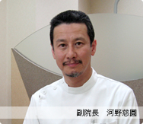Deputy Director: Dr.Jien Kono

**Jien.Kono.DDS. Phd**

Birthday: August 16th 1956

* 【Educational History】
* Graduated from Osaka Kyoiku Univ.attached Tennoji High School
* Graduated from Nihon University School of Dentistry
* Doctor of Medical Dentistry(Phd) from Osaka Dental University
* 【Present Post】
* [Kono Dental Clinic/ Deputy Director](http://www.kono-dental.com/english/)
* Specialist of Bio-Progressive Orthodontics
* [Approval Doctor Instructor of Ministry of Health, Labour and Welfare Doctor Instructor of Intern・Approval Clinic of Intern Training](http://www.d-reisjp.org/common/ad0.php)
* Deputy Priest of Tendai-shu Fukuju-zan Jiko-ji
* [Tendai Buddhist](http://en.wikipedia.org/wiki/Tendai)

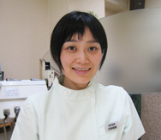

**Dr.Jie Kono**

Jie.Kono.DDS

Birthday: November 1979

* 【Educational History】
* Graduated from Osaka Kyoiku Univ.attached Tennoji High School
* Graduated first on the list from Okayama University in 2004
* Completed dental-internship of Osaka Dental University in 2005
* [Master of Silva Method](http://www.silvamethod.com/)
* Aromatherapy Instructor of AEAJ (The Aroma Environment Association of Japan)

**Contact us**

